1. Brief Description of what topic or technology you are concentrating on:

This lab’s focus was on configuring routers on a wan connected by their serial interface ports.

2. Topology:

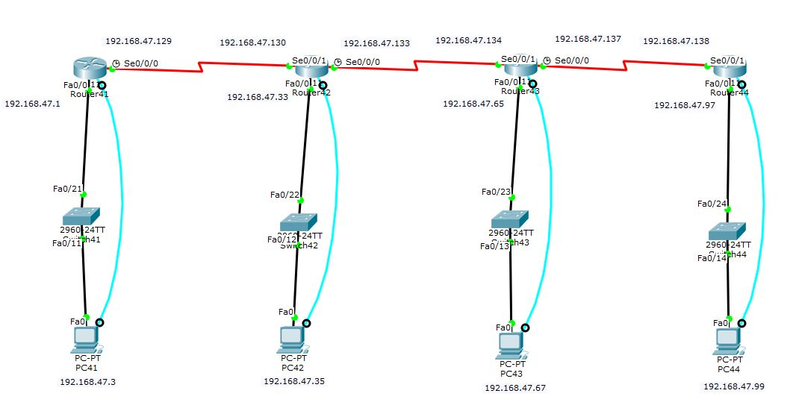

3. Table of new Command Syntax and the associated description:

|  |  |
| --- | --- |
| Command | Description |
| Show ip int | Shows all address information on the router |
| Show ip int brief | Shows a brief table of only essential address information on the router |

4. Verification:

-router41:

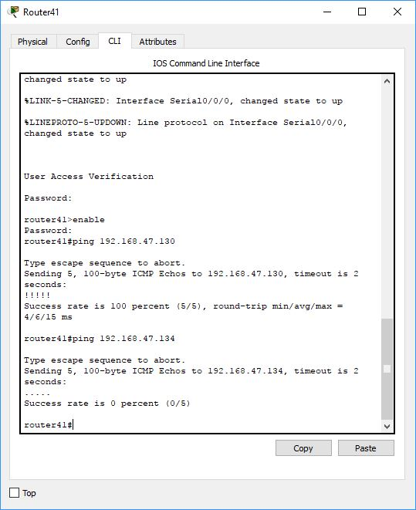

-router42:

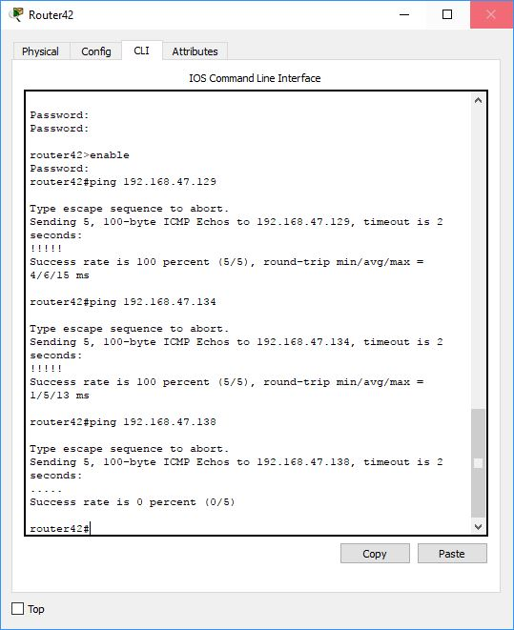

-router43:

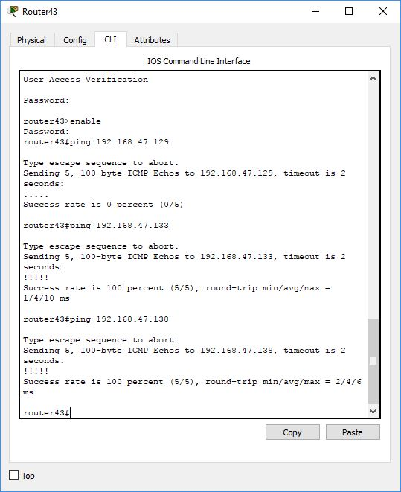

-router44:

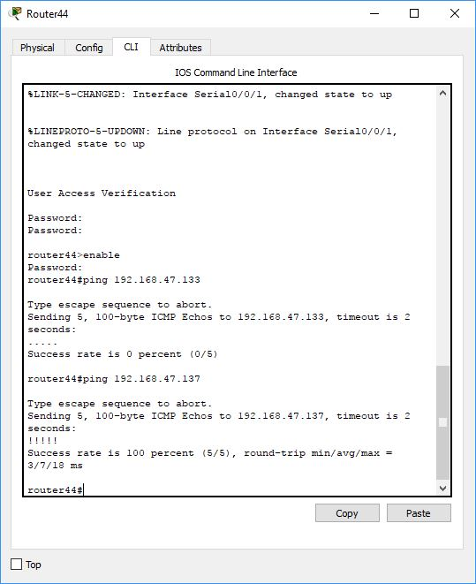

5. Results / Outcomes: From a router I could ping a router directly adjacent, but no further. This would match what happened in class so I believe it is the correct behavior.